1 PARTS DESCRIPTION
Connection | Wiring
Terminal | Hole
 |  | Main Body
Cover | Indication
 | Lamp
Vertical Angle Adjusting Screw
Lens
Screw Locking 2. Obscuration Time Adjustment
(Only for receiver)
1. Monitor Jack
(Only for receiver)
Tamper
Viewfinder
Horizontal Angle Adjusting Bracket
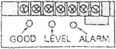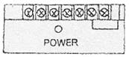

1. Indication Lamp Receiver:
Level (Red) Brightness varies, depending on incident level.
Alarm (Red) On indicated alarm.
Good (Green) On indicates normal conditions, beam aligned.
Receiver 1. Monitor Jack: Should be used for making the optimum optical axis adjustment. (Refer to “how to use monitor jack”)
2. Obscuration time adjustment: To be used for setting the obscuration time to alarm. (Refer to “adjustment of obscuration time”)
Transmitter
• Power (Green) Transmitter On indicates power is normal.

2 SUGGESTIONS FOR INSTALLATION
Do not install in the following conditions:
Ensure strong sunlight or Ensure the sensor’s line of Ensure the sensors car headlights do not shine sight is free from any false are mounted on a directly on to the receiver.
alarm sources such as stable and firm foot-(Within ±2° from the optical bushes, trees, etc. (Pay at-ing. axis is not recommended). tention to these as they may change seasonally).

Height of installation and protection distance:
33
Note that here the model references do not match the Pro-14 tection Distance of Spread of Beam.
Spread of Beam
Height of Installation 0.7—1.0 m
 | Protection Distance | Spread of Beam
ABT-60 | 60 m | 1.8 m
Direction of Installation:
 | Vertically 20° (±10°)
33
Protection Distance
Rcv. X-mit Rcv. X-mit
In case of jump phenomena as shown in the above sketch of long distance links, units are available with modified pulse frequencies on request.
Because angle of reflection mirror is adjustable ±90° horizontally and ±12° vertically, the unit can be installed in various directions.
Horizontally 180° (±90°)
Rcv. X-mit Rcv. X-mit

3 INSTALLATION

Wall Mount:
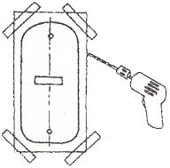Knock Out
Loosen screw holding cover and remove the cover.
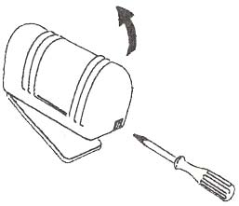Attach the mounting pattern paper to the wall, mark the installation holes, and make the guide holes.
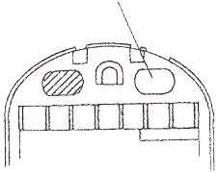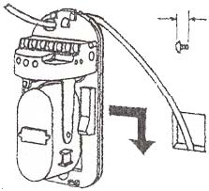
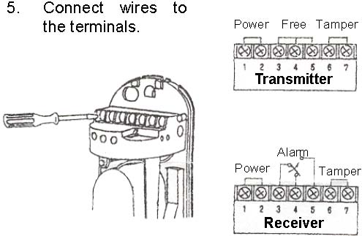
6. Make the optimum optical adjustment as per section 4, and confirm system operation before replacing covers.
Wiring Distance
Model | ABT-60
Diameter of Wire Voltage | 12 V | 24 V
0.30 mm2 (∅0.6) | 250 m | 210 m
0.50 mm2 (∅0.8) | 430 m | 360 m
0.75 mm2 (∅1.0) | 680 m | 610 m
1.25 mm2 (∅1.2) | 980 m | 870 m

Pole Mount:
(Suggested pole diameter Ø38 - Ø48 mm)
1. | Pull the wire | 2. | Route | the | wire | 3. | Route the wire | 4. | Attach | the
through | the | through the main |  | through | the |  | pole to | the
wire hole of | body of the detec |  | flange and | at- |  | flange.
the pole. | tor and attach the |  | tach the flange
detector | to | the |  | to the pole with
flange. |  |  |  | the pole mount
 |  | ing bracket.
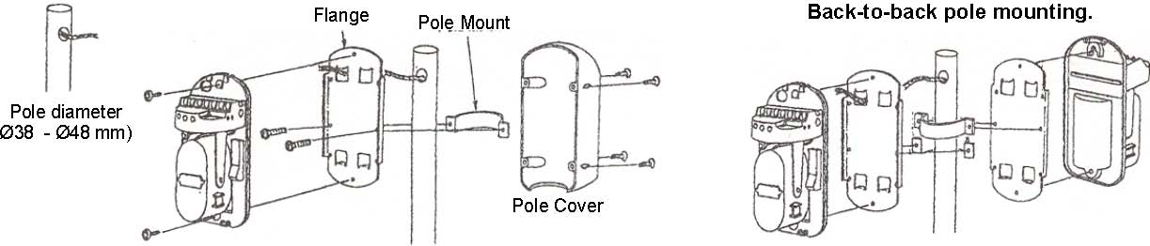

4 ADJUSTMENT OF OPTICAL AXIS

(Aiming Beam)
1. | Remove | transmitter | and | 2. | In each unit, remove the | 3. | At the transmitter, look through the
 | receiver covers and apply |  | viewfinder from it’s normal |  | viewfinder, with your eyes about 10 cm.
 | power to the units. |  | storage location and place |  | From it. | Adjust the horizontal angle
 |  |  | it, as shown, on one of the |  | bracket and (with a small screwdriver)
 |  |  | holders on either side of the |  | the vertical angle screw. | When the
 |  |  | lens. | Use whichever side |  | transmitter’s optical axis | is | properly
 |  |  | permits sighting through the |  | adjusted, the image of the receiver will
 |  |  | viewfinder in the next step. |  | be seen in the center of the viewfinder.
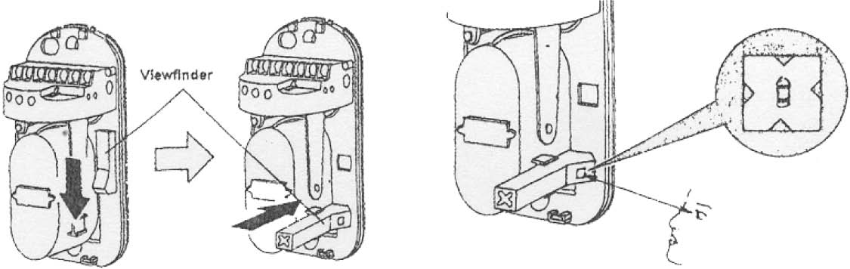
4. Repeat step 3, but at the receiver. When the transmitter’s image is seen in the center of the receiver’s viewfinder, the receiver’s GOOD (green) monitor LED should be on as confirmation of proper alignment (if off, carefully repeat steps 3 and 4).
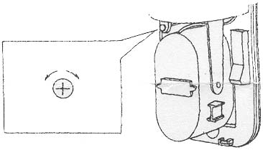
NOTES:
The brightness of receiver’s LEVEL (red) LED will vary with the accuracy of alignment. The better the alignment, the brighter the LED.
The best adjustment of optical axis can be done by reading the outputvoltage of the monitor jack.
Insert the meter pins into the monitor jack. (Pay attention to the polarity because of DC voltage.)
a) Adjust the horizontal angle bracket until the output is at maximum. b) Adjust the vertical angle screw to obtain maximum signal. (Do not interrupt beam by hands during the adjustment.)
The minimum voltage (2.3V) should be obtained to ensure best performance. (If this is not obtained then Transmitter and Receiver should be
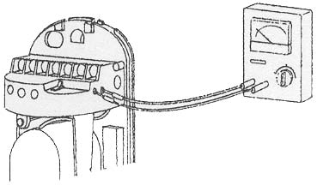
re-aligned.)

5 ADJUSTMENT OF SHADING TIME
Set the obscuration time of the receiver by adjusting the obscuration time control to the required setting according to the sketch to the right.
The obscuration time should be set lower to detect faster moving targets, however care should be taken to note the environmental con-Obscuration ditions as the obscuration time should be set Time Control higher to ignore conditions where there are a lot of birds or wind-blown material.

6 CONFIRM OPERATION

Scale 1 Fast Running at Full Speed (6.9 m/s) | Scale 2 Walking with Quick Steps | Scale 3 Normal Walking (0.7 m/s) | Scale 4-5 Slow Action (0.3—0.5 m/s)
After completion of the installation, confirm correct operation by suitable walk tests. Refer to the following LED indications during the walk test.
Confirm Tamper operation prior to replacing covers.
Confirm system operation with covers replaced.
 | Condition | Indication
Transmitter | Transmitting | Green LED is ON
Receiver | Watching | Alarm indicator is OFF
 | Alarm | Alarm indicator is ON

7 TROUBLESHOOTING GUIDE
Symptom | Possible Cause | Remedy
Transmitter LED does not light. | Improper voltage supplied. | Check power supply and wiring.
Receiver power LED does not light. | Improper voltage supplied. | Check power supply and wiring.
Alarm LED does not light, even when beams are blocked. | Infrared beam from transmitter is reflecting from another object and is being sent into the receiver. | Remove reflecting object or change installation location and optical axis direction.
 | Two beams are not blocked at the same time. | Check two beams to assure blocking at same time.
 | Shorter blocking than the time set. | Adjust blocking time to be longer.
Although Alarm LED lights when beams are blocked, alarm doesn’t sound. | Broken or shorted alarm output wires. | Check the wiring.
 | Blown fuse on the signal circuit. | Repair as required.
Alarm LED on receiver does not turn off. | Optical axis not aligned. | Readjust the optical axis.
 | Blocking object between transmitter and receiver. | Remove the blocking objects.
 | Dirty cover or reflecting mirror at transmitter and/or receiver. | Clean optics with soft cloth.
Intermittent Alarm | Bad wiring connection. | Check wiring connection.
 | Change of supply voltage. | Check for stabilized voltage.
 | Blocking objects blowing between transmitter and receiver. | Remove blocking objects or change installation location.
 | Unstable sensor mounting. | Stabilize mounting.
 | Marginal optical axis alignment. | Readjust the optical axis.
 | Birds or other large flying objects interrupting the beams. | Readjust blocking time or relocate installation.

8 SPECIFICATIONS
Model | ABT-60 | ABT-80
Protection Distance | Indoor | 60 m | 80 m
 | Outdoor | 180 m | 240 m
Max. Arrival Distance | 650 m | 800 m
Infrared Beam | 2 Beams
Detection System | Simultaneous cut-off of 2 beams
Light Source | Infrared LED
Response Time | 50-700 m/sec
Alarm Signal | Form ‘C’ (SPDT) relay contacts Rating: 0.5A max at 30 VAC, DC
Supply Voltage | DC 10.5 - 28V
Current Consumption | 55 mA Max. | 65 mA Max.
Temperature Range | -25°C - 55°C
Dimensions (H X W X D) | 171 X 82 X 77 mm
Tamper Range | Form ‘B’ (SPST) relay contacts
Optical Axis Adjustable Angle (Horizontal) | 180° (±90°)
Optical Axis Adjustable Angle (Vertical) | 20° (±10°)
Collimator | Viewfinder with peep window
Measure for Moisture/Frost | Sit type cover
Other Additional Functions | Alignment LED and Monitor Jack
Material | ABS Plastic
Weight | 300 g (Transmitter & Receiver)

9 OUTER DIMENSIONS
Flange & Pole Mounting Bracket
Ø38 - 50 mm
